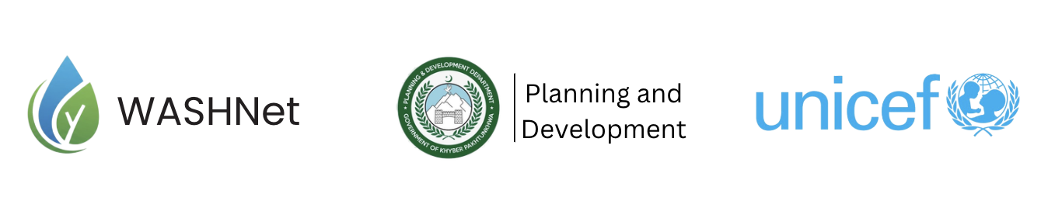
Concept Note

Proposed Thematic Workshop - Strengthening Shared Value Partnerships Parliamentarians and Communities Working Together for Sustainable Development

UNICEF in collaboration with the Planning and Development Department, Government of Khyber Pakhtunkhwa
Target Participants: Approx. 25 Members of the Khyber Pakhtunkhwa Provincial Assembly
Duration: 1 Day (2–3 hours)
Approach: Interactive, case-based, and solution-oriented

1. Rationale and purpose
Effective constituency development depends on strong relationships between parliamentarians and their communities. When engagement is consistent and inclusive, it leads to better identification of local priorities - particularly in essential areas such as water, sanitation, and hygiene (WASH), health, and infrastructure. This workshop aims to strengthen these linkages through practical and experience-based discussions.

2. Objectives
The session is designed to equip participants with practical insights and approaches that can be applied within their constituencies. In particular, it will:
- Develop simple, actionable plans for community engagement
- Identify ways to translate community needs into policies and development initiatives
- Promote participatory approaches in key sectors like WASH and local infrastructure

3. Sessions
Session 1 - The Power of Community Trust

Discussion Points
- Why communities support leaders who listen and respond
- Difference between short-term political promises vs long-term community trust
- Examples of successful constituency leadership

Activity
Participants discuss:
“What are the three biggest expectations your constituents have from you?”
Facilitator lists common themes (water, health, roads, education).

Session 2 - The Win-Win Model for Parliamentarians

Discussion Points
Aligning community needs with development priorities to ensure mutual benefits - improved service delivery for citizens and strengthened public trust for parliamentarians
Community Gains | Parliamentarian Gains
Better services | Strong public reputation
Voice in decision-making | Increased voter trust
Transparent development | Sustainable political support
Ownership of projects | Reduced conflicts and complaints

Practical Tools for Constituency Engagement
To translate these ideas into action, the workshop will introduce a few simple but effective tools that can be adapted across constituencies:
- Constituency forums for regular public dialogue
- Community committees with inclusive representation
- Participatory planning before budget allocation
- Transparency measures for public awareness of development schemes

4. Expected Outcome

Participants will gain practical insights and simple tools to engage communities more effectively, address key development challenges - including WASH - and build long-term trust through transparent and responsive leadership.

